**Maths year 7 & 8 summer resources**

|  |
| --- |
| **YEAR 7 & 8   TOPICS** |
| Integer place value |
| Mental addition and subtraction |
| Written addition and subtraction of integers |
| Addition and subtraction of decimals |
| Multiplication and division of integers |
| Area |
| Multiplication and division of decimals |
| Mean |
| Time |

The rest of this booklet contains questions in the style that you will find in the assessment. Plan to do 2 page per week– or follow your teacher’s instructions.

**1.**

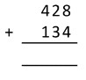2 marks 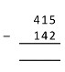2 marks

1. Write these numbers in order from smallest to largest

16, 123, 73, 140, 77

1 marks

1. Write down the value of the 3 in the number 42 398

1 marks

**4.**

work out

* 1. 7 x 10

………………..

* 1. 3.6 x 100

………………...

* 1. 0.054 x 100

…………………………

* 1. 6000 ÷ 100

………………………….

* 1. 0.84 ÷ 10

…………………..

(5 marks)

**5.** (a) Round 342 to the nearest ten

(1mark)

(b) Round 12 831 to the nearest thousand

*(1mark)*

**6.**

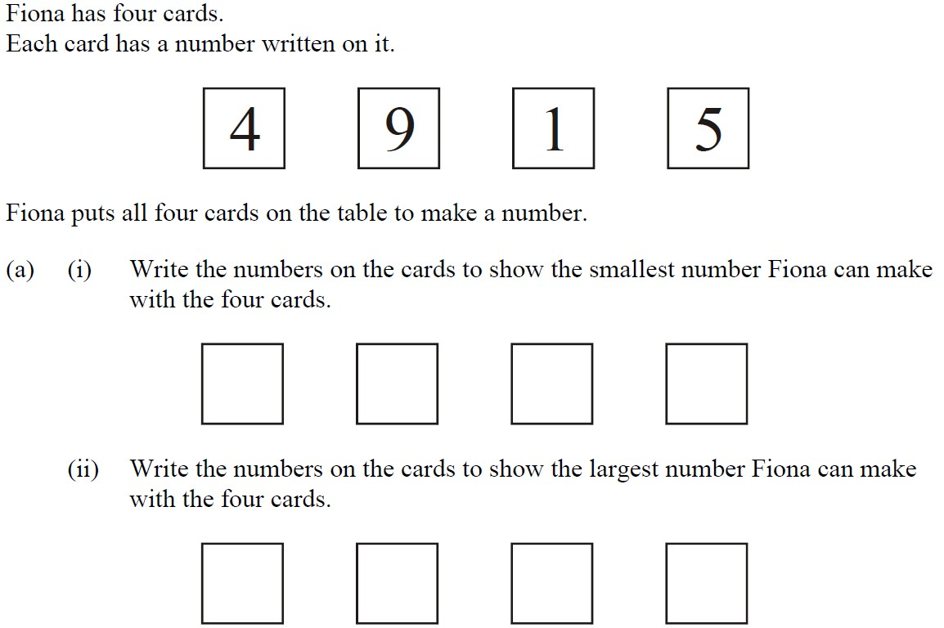1 mark

1 mark

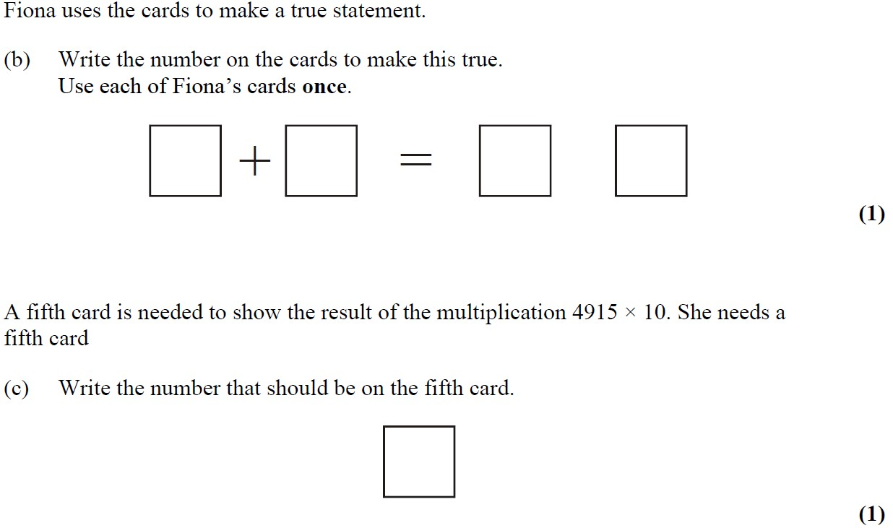1 mark

1 mark

**7.**

Tony has a hot-dog stall.

He uses sauce from a bottle which holds 224 ml.

He puts about 7 ml of sauce on each hot-dog.

How many hot-dogs can he put sauce on from one bottle?

(2marks)

**8.**

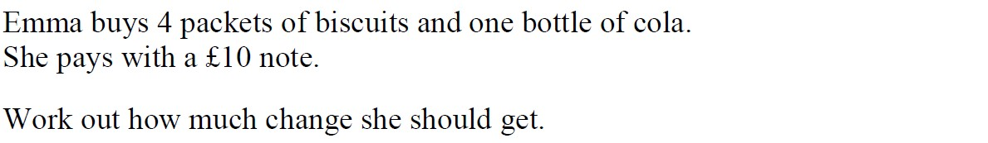

*(3 marks)*

1. Calculate the perimeter of the shape below giving units with your answer

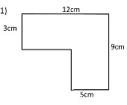

* 1. *marks)*

1. The three triangles in the diagram below are exactly the same. Calculate the total area of the shape. Give units with your answer

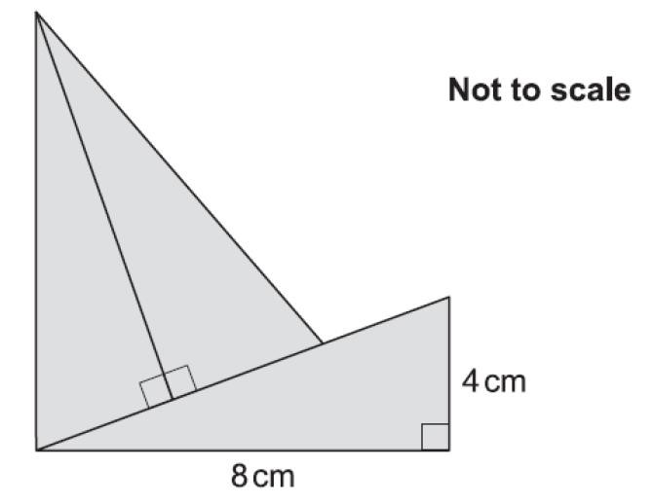

1. Write the number **7428** in words.

.............................................................................................................................................

(1)

The mountain K3 is eight thousand and fifty one metres high.

1. Write the number **eight thousand and fifty one** in figures.

...........................................................



The table shows the heights of six mountains.

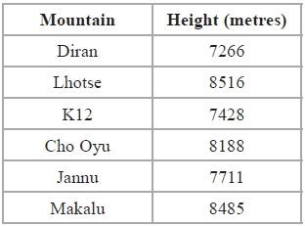

1. Write down the name of the highest of these mountains.

...........................................................



1. Write the number **8188** to the nearest hundred.

...........................................................

(1)

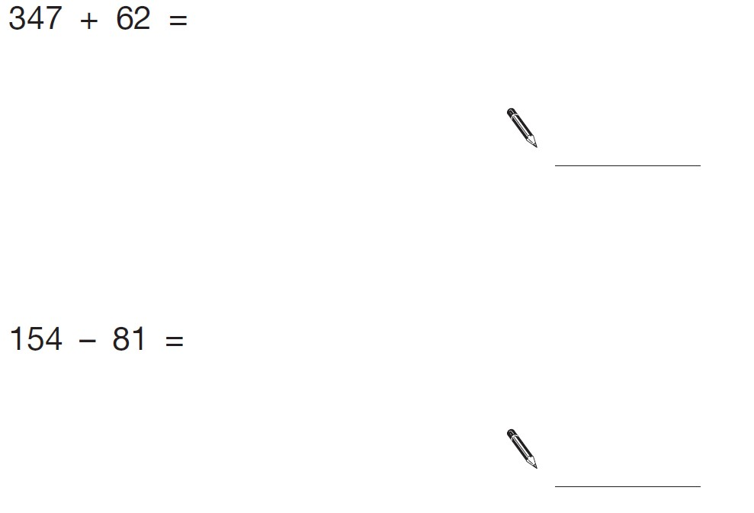(2)

(2)

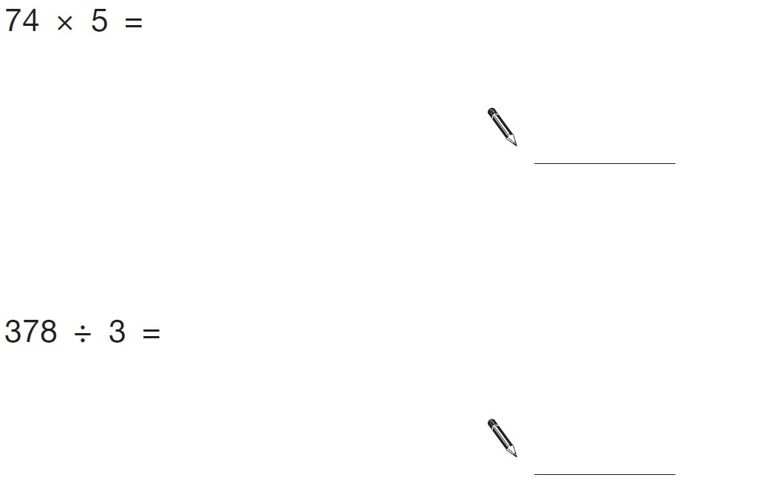(2)

(2)

Write the correct symbol =, < or > in each circle

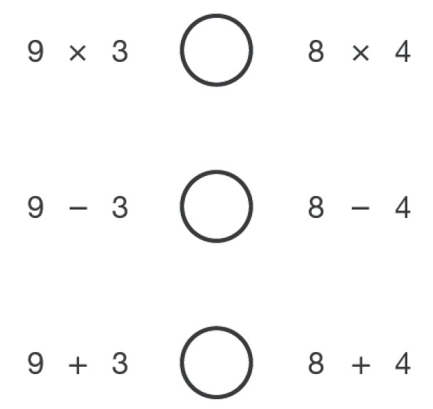

(3)

1. Write these numbers in order of size, starting with the smallest.

**3.01** **13.0**  **0.31**  **1.30**  **3.1**

**Smallest**

2 marks

1. Complete the table by rounding each number to the accuracy given at the top of the column.

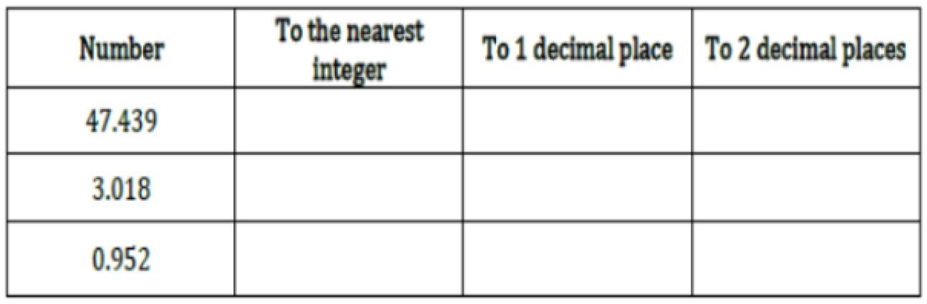

**6.**

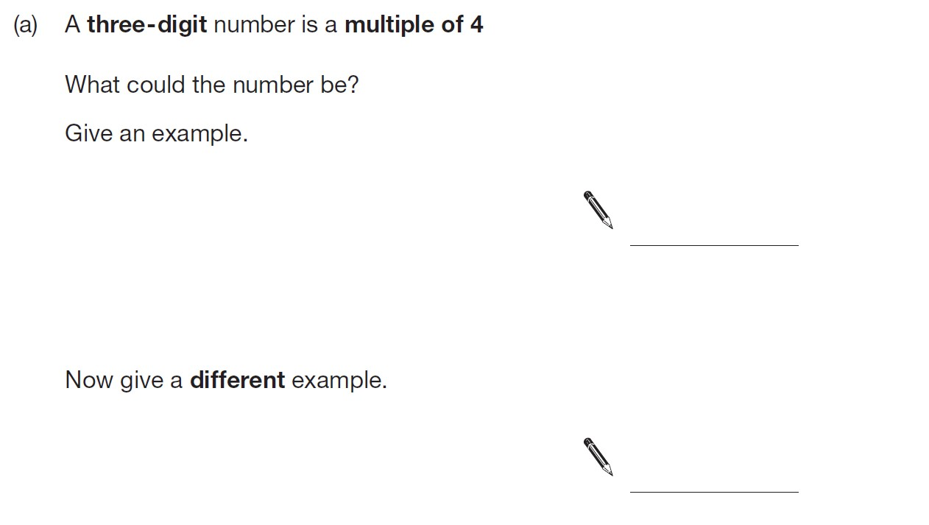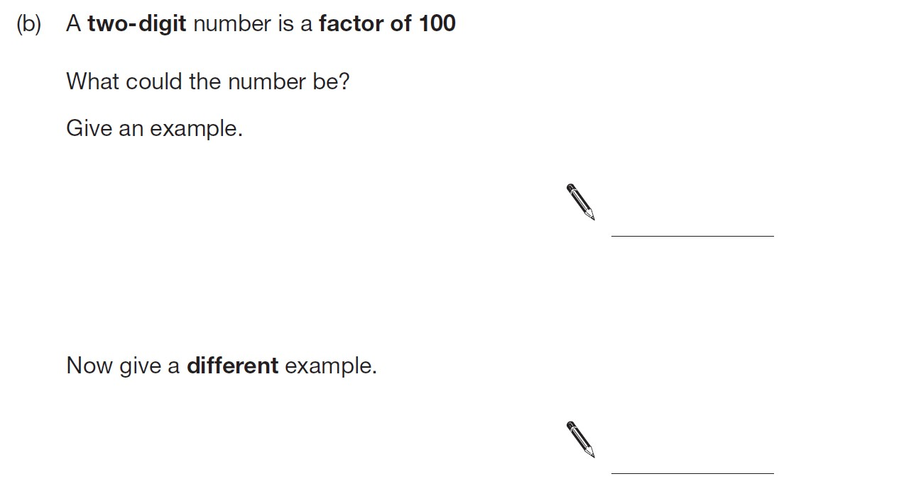

1

mark

1

mark

1

mark

1 mark

**7.**

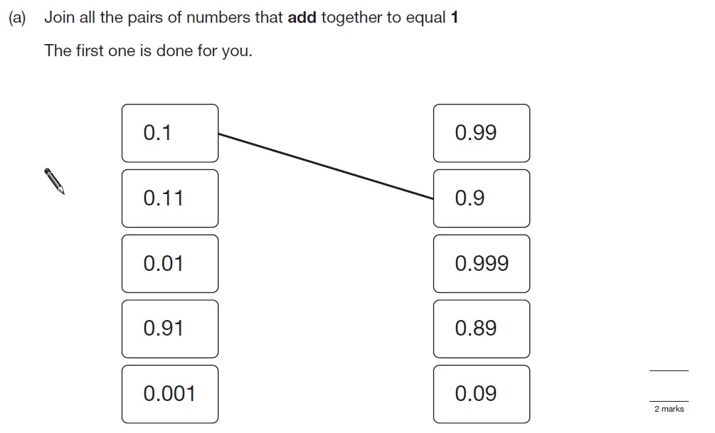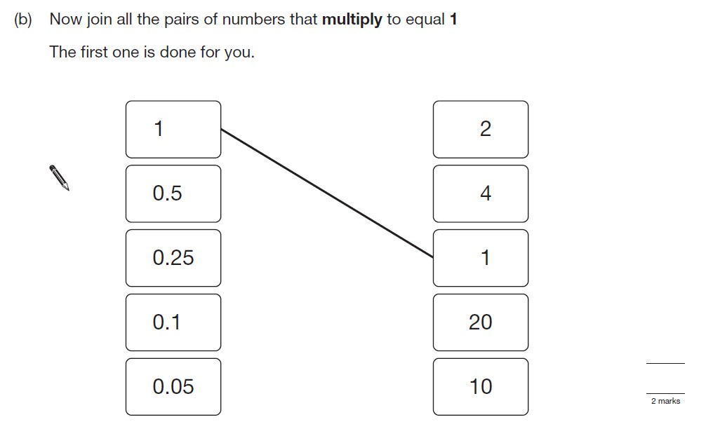

**8.**

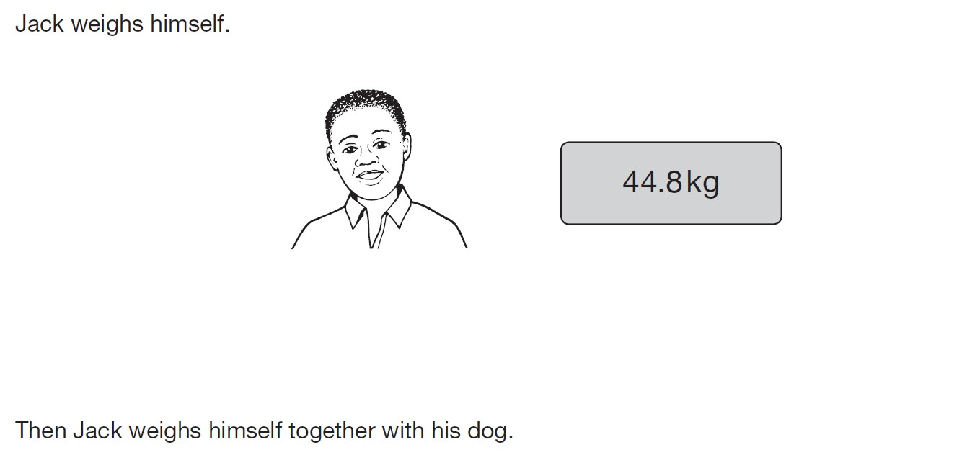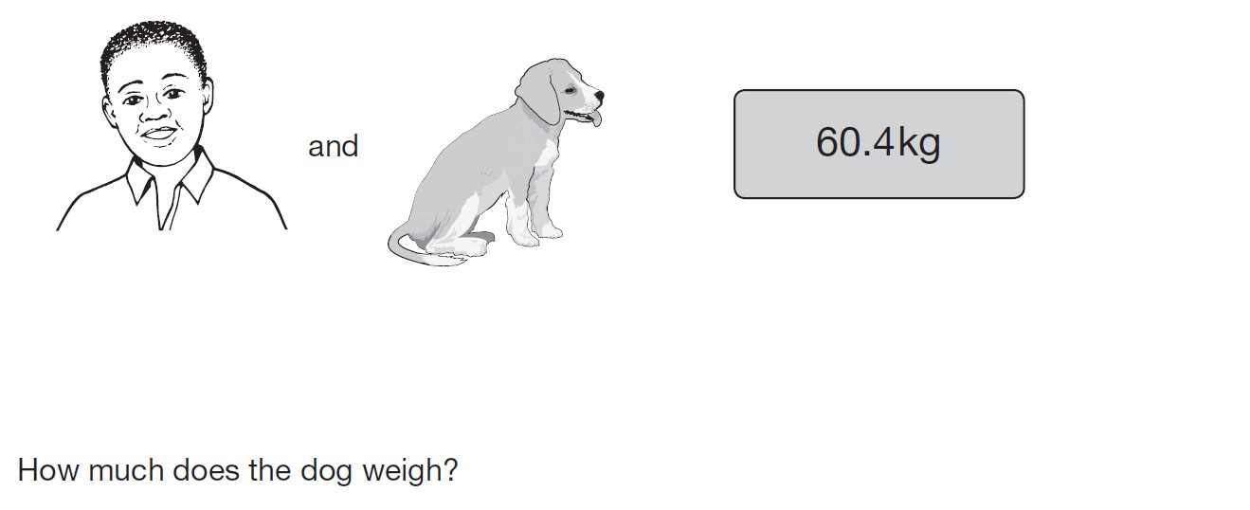

3 mark

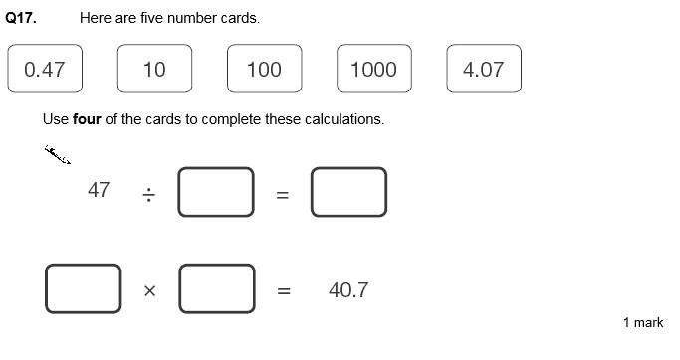

**9.**

2

mark

You can use each card only

once

**10.**

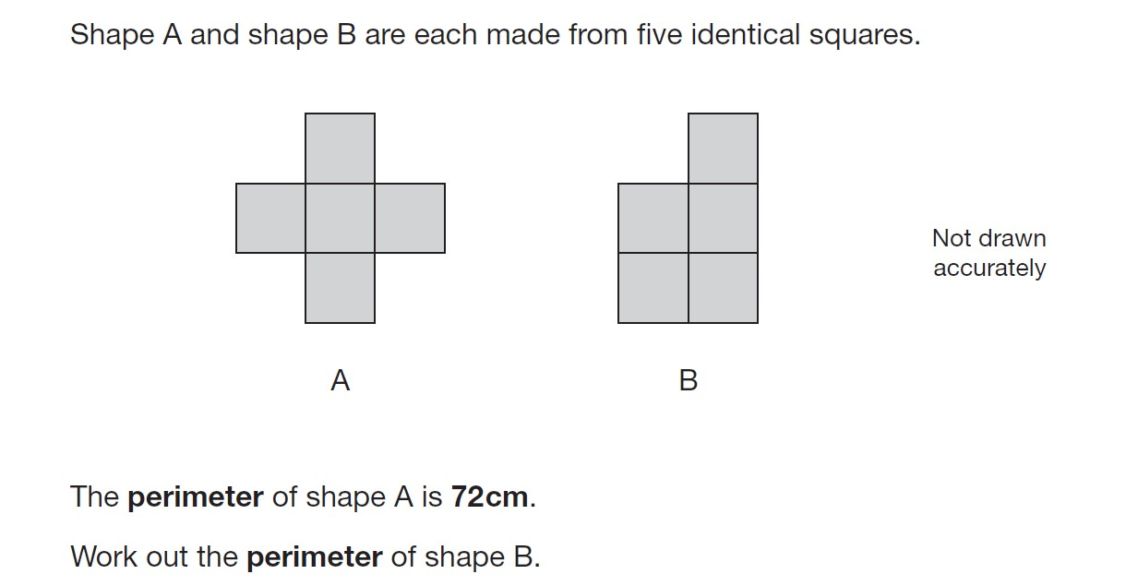

3 mark

**11.**

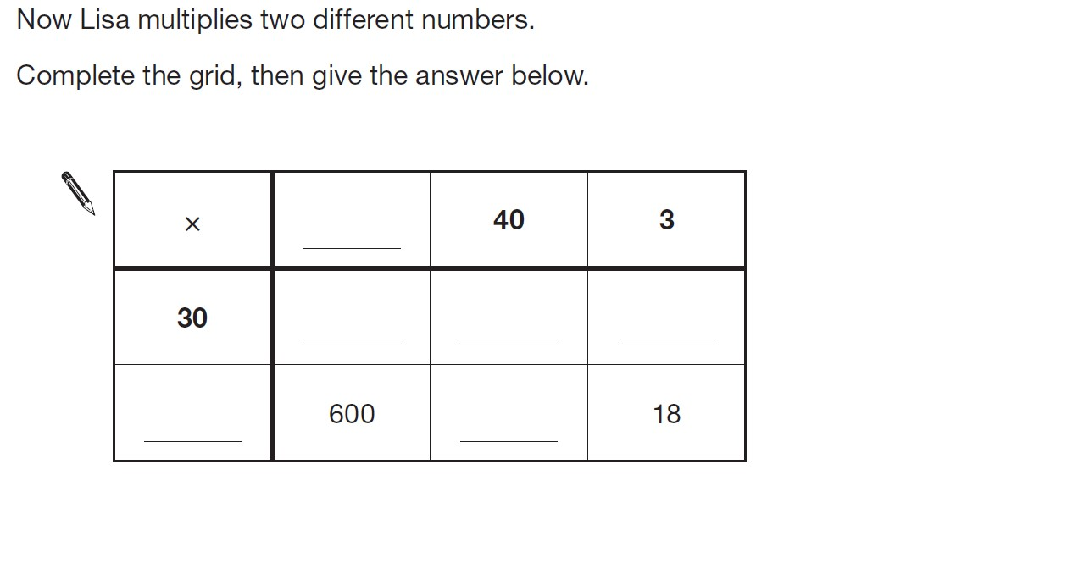

4

mark

**12.**

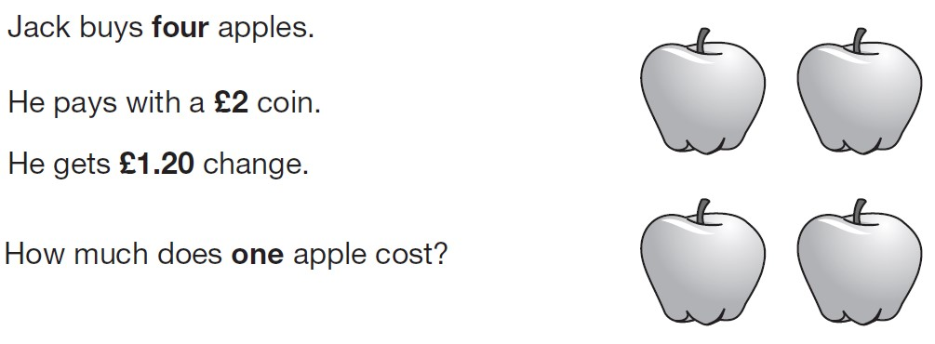

3 mark

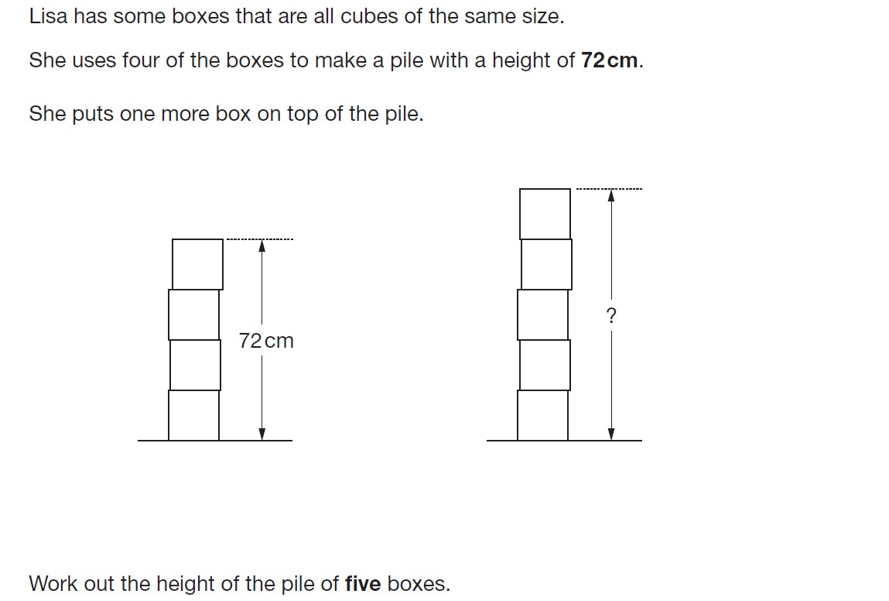**13.**

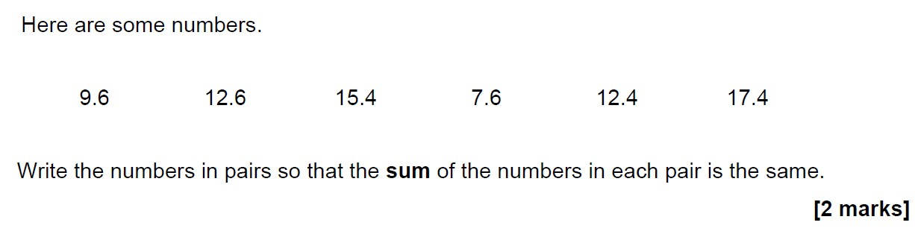**14.**

**15.**

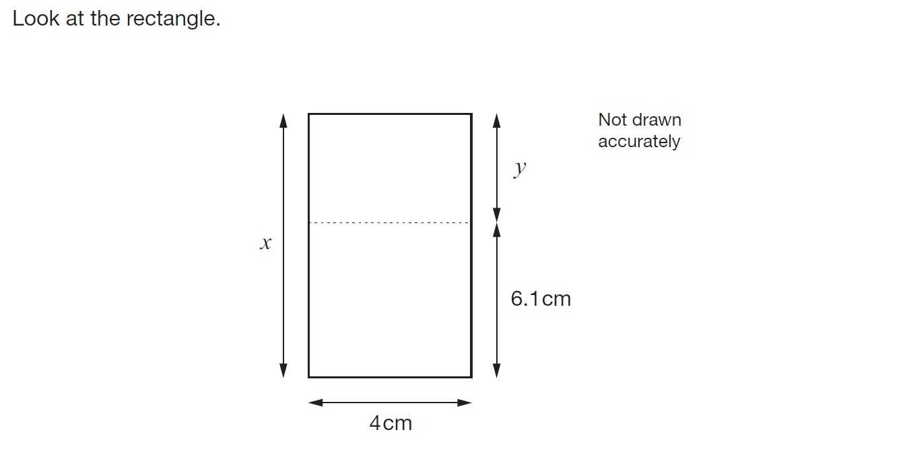

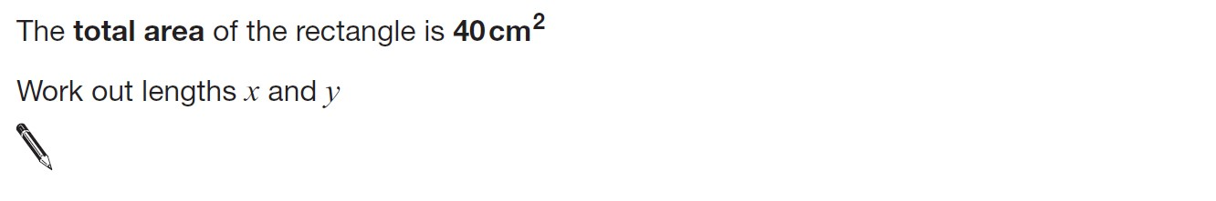

3 mark

**16.**

